Chapter 4: Results

**Introduction**

This study explored the correlation between religious attitudes toward traditional biomedical and psychological services and the perceived fear of such services among Christian adults (Catholic or Protestant) in Southern California religious communities and colleges. It investigated how religious attitudes influence the choice of counseling service. Furthermore, research analysis focused on the choice of counseling service and its correlation with potential delays in reporting mental illness when seeking traditional biomedical and psychological providers. As a result, this chapter will offer the study findings that encompass a description of the sample population's demographic characteristics, descriptive statistics for the key variables, and statistical assumptions analysis using Pearson correlation analysis. The sections included are the introduction, data collection, results of analysis; and summary.

**Research Questions and Hypotheses**

This chapter will address the research questions and hypotheses as follows:

RQ 1: What is the correlation between religious attitudes and perceived fear of traditional biomedical and psychological services among Christian adults?

**H10**: There is a correlation between religious attitudes and perceived fear of traditional biomedical and psychological services among Christian adults.

**H1a**: There is no correlation between religious attitudes and perceived fear of traditional biomedical and psychological services among Christian adults.

RQ 2: What is the correlation between perceived fear of traditional biomedical and psychological services and choice of service for counseling among Christian adults?

**H20**: There is a correlation between perceived fear of traditional biomedical and psychological services and choice of service for counseling among Christian adults.

**H2a**: There is no correlation between perceived fear of traditional biomedical and psychological services and choice of service for counseling among Christian adults.

RQ 3: What is the correlation between the choice of service for counseling and delay of mental illness reporting among Christian adults?

**H30**: There is a correlation between choice of service among Christian adults and delay of mental illness reporting.

**H3a**: There is no correlation between choice of service among Christian adults and delay of mental illness reporting.

**Data Collection**

This study used survey questionnaires to collect data. A self-administered questionnaire was used to gain demographic and personal information from the participants. The questionnaire included religious-oriented items and items concerning individual preferences for psychological or church counseling. Furthermore, the questionnaire included questions on participants' experiences with psychological or church counseling. The second means of collecting data was electronic, using SurveyMonkey. The participants were exclusively Christians who resided in South California. Before analysis, data were cleaned and categorical data coded for correlation analysis. The pairwise deletion was conducted for the “level of a college education” for entries that were not relevant to the data.

**Study Sample**

Adults from different religious communities in Southern California, including churches, community centers, and universities, were the main subjects of the study. The first requirement for inclusion in the study was that participants identified as belonging to a Christian denomination or nondenominational organization, and the second requirement is that they reside in the Southern California region. Using this population's size of about 2 million people, the target sample size was 128 people.

Adult Christians (Catholic or Protestant) from diverse demographic groups who attend religious institutions and colleges in Southern California make up the sample population for this study. There were 133 participants in the sample, of which 64 (48.1%) are women and 69 (51.9%) are men. In terms of age distribution, the sample includes people from a range of ages. The bulk of participants—41, or 30.8%—are in the 30- to 39-year-old age range. Age group 21-29 make up the second-largest group, with 22 (16.5%) participants. Each of the age categories 40-49 and 50-59 had 23 (17.3%) participants. With 9 (6.8%) people, the age group 18-20 has the smallest representation, and 15 (11.3%) of the sample's participants are 60 or older.

Participants have a range of educational backgrounds in terms of educational levels. Individuals with "some college but no degree" include three (2.3%), those with associate degrees include 11, those with bachelor's degrees include 30, and those with graduate degrees include twelve (9.0%). Only 4 (3.0%) of the sample's participants indicated they do not identify as Christians, compared to 129 (97.0%) who responded "yes" to the question. The sample reflects a variety of groups with Christian denominational affiliation. "Other," with 60 (45.1%) participation, is the largest denominational group. While the "Protestant (General)" category has the lowest representation with only 1 (0.8%) participant. The Orthodox and Evangelical (Non-denomination) groups each have 36 (27.1%) participants.

A total of 128 (96.2%) of the participants said they presently live in Southern California, while 5 (3.8%) said they do not. The percentage of individuals who attend religious services in the Southern California region is 105 (78.9%), whereas 28 (21.1%) do not. The sample comprises members with various levels of commitment in their respective churches. The majority of participants, 61 (45.9%), describe themselves as "Not very involved," followed by 53 (39.8%) who describe themselves as "Moderately involved," and 19 (14.3%) who describe themselves as "Very involved" through involvement in ministries and volunteering.

**Table 1**

*Demographic Characteristics of the Sample Population*

|  |  |  |
| --- | --- | --- |
| **Categorical Variable** | **Frequency** | **% of Total** |
| Gender |  |  |
| Female | 64 | 48.1 |
| Male | 69 | 51.9 |
| Age |  |  |
| 18-20 | 9 | 6.8 |
| 21-29 | 22 | 16.5 |
| 30-39 | 41 | 30.8 |
| 40-49 | 23 | 17.3 |
| 50-59 | 23 | 17.3 |
| 60 or older | 15 | 11.3 |
| Level of College |  |  |
| Some college but no degree | 3 | 2.3 |
| Associate degree | 11 | 8.3 |
| Bachelor’s degree | 30 | 22.6 |
| Graduate degree | 12 | 9.0 |
| Do you identify as a Christian? |  |  |
| Yes | 129 | 97.0 |
| No | 4 | 3.0 |
| What denomination of Christianity do you identify with? |  |  |
| Orthodox | 36 | 27.1 |
| Protestant (General) | 1 | 0.8 |
| Evangelical (Non-denomination) | 36 | 27.1 |
| Other | 60 | 45.1 |
| Do you currently live in the Southern California area? |  |  |
| Yes | 128 | 96.2 |
| No | 5 | 3.8 |
| Do you attend religious services in the Southern California area? |  |  |
| Yes | 105 | 78.9 |
| No | 28 | 21.1 |
| How involved are you in your church? (ministries, volunteering) |  |  |
| Not very involved | 61 | 45.9 |
| Moderately involved | 53 | 39.8 |
| Very involved | 19 | 14.3 |

**Results**

**Descriptive Statistics**

This section presents the key findings and analyses from the study exploring the correlation between religious attitudes toward traditional biomedical and psychological services and the perceived fear of such services among Christian adults in Southern California religious communities and colleges. The results provide valuable insights into the relationships between these variables and shed light on how religious attitudes influence the choice of counseling service. Additionally, the section examines the correlation between the choice of counseling service and potential delays in reporting mental illness when seeking traditional biomedical and psychological providers.

In the framework of their Christian religion, participants' attitudes, convictions, and perceptions of conventional biomedical and psychological services are covered by the topic of religious attitudes. It captures the degree to which people agree or disagree with religious ideas or teachings about receiving mental health care from nonreligious sources (Kassis & Papps, 2020). This variable is essential to understanding how people's perspectives on conventional mental health services are influenced by their religious convictions.

Regarding standard biomedical and psychological therapies within the context of their Christian religion: participants' attitudes, beliefs, and perceptions are referred to as their "Religious attitudes." It captures how closely or differently people abide by religious ideas when seeking out nonreligious sources of mental health care (Kohrt et al., 2020). This variable is very important in examining how people's attitudes toward conventional mental health services are influenced by their religious beliefs.

The participant's reported worries about using conventional biomedical and psychological therapies are captured in the study's "Perceived Fear of Traditional Services" variable. It covers feelings like worry, trepidation, or resistance to seeking help from secular mental health professionals. The identification of potential obstacles or stigmas that might influence people's decision-making processes while thinking about conventional mental health support is made easier with an understanding of this variable (Kassis & Papps, 2020).

"Choice of Service for Counseling" refers to the types of counseling services that participants prefer to use while seeking mental health care. It makes a distinction between psychological counseling offered by experts in the secular world and counseling offered in a religious setting at a church (Li et al., 2023). This variable is crucial to understanding how people's preferences for mental health services may be influenced by perceived fear and religious sentiments.

Any delays in seeking treatment for mental illness from conventional biological and psychological providers are referred to as "Potential Delays in Reporting Mental Illness" and are related to the counseling service of choice. To get insight into potential delays or early intervention techniques within the Christian population, it investigates if participants' choice of counseling service impacts the timing of seeking professional mental health help (Pereira et al., 2013).

The participant's views, perceptions, and attitudes toward conventional biomedical and psychological services within the framework of their Christian faith are represented by the variable "Religious Attitudes" in this study. A total of 133 individuals' responses make up the data. The mean score is 39.48, with scores ranging from 25 to 67. As a result, it can be concluded that participants' attitudes toward mental health services are generally relatively in line with or influenced by their beliefs. The attitudes appear to range around the mean, showing some variability in participant viewpoints, according to the standard deviation of 9.00. Given that more participants tend to have slightly higher scores in religious attitudes, the distribution of religious attitudes is slightly positively skewed (skewness = 0.741). With a mesokurtic pattern (kurtosis = 0.36), the distribution similarly resembles a normal distribution in that the data are moderately peaked.

Regarding conventional biomedical and psychological services, participants' feelings of anxiety or apprehension are represented by the variable "Perceived Fear". A total of 133 individuals' responses are included in the data. With an average score of 54.23, the felt terror ratings range from 19 to 90. This shows that participants' overall apprehension toward conventional services is modest. The subjects' responses varied significantly around the mean, as shown by the standard deviation of 15.53, which offers significant heterogeneity in the felt fear levels. According to the distribution of "perceived fear", which is significantly negatively skewed (skewness = -0.19), more participants often report feeling less scared. Additionally, the distribution has a platykurtic pattern (kurtosis = -0.15), indicating that the data is slightly flatter than would be expected from a normal distribution.

When participants seek mental health care, the variable "Choice of Service for Counseling" reflects their preferences for the counseling service they prefer. A sum of 133 individuals' responses are included in the data. The range of choice scores is 27 to 99, with a mean of 59.40. This suggests that participants, in general, favor secular psychological therapy services over religious treatment. The 12.42 standard deviation implies some variation in the individuals' preferences relative to the mean. A balanced distribution of preferences between secular and church-based counseling services is shown by the distribution of choice of service, which is almost symmetrical (skewness = -0.01). Additionally, the distribution displays a leptokurtic pattern (kurtosis = 0.793), which denotes that the data has slightly heavier tails than expected from a normal distribution.

The variable "Choice of Service for Counseling" indicates the counseling service preferences of participants when they seek mental health care. The data includes replies from a total of 133 people. Choice scores vary from 27 to 99, with a mean of 59.40. This implies that participants favor secular psychological therapy over religious therapy in general. The 12.42 standard deviation suggests that the individuals' choices can differ from the mean in various ways. The distribution of service preference, which is nearly symmetrical (skewness = -0.01), demonstrates a balanced distribution of preferences between secular and church-based counseling services. The distribution also exhibits a leptokurtic pattern (kurtosis = 0.793), which indicates that the data has slightly heavier tails than would be predicted from a normal distribution.

**Table 2**

*Descriptive Statistics of The Main Independent and Independent Variables*

|  |  |  |  |  |
| --- | --- | --- | --- | --- |
| **Parameters** |  |  |  |  |
|  | **Religious attitudes** | **Perceived Fear** | **Choice of Service for Counseling** | **Delay of Mental Illness** |
| N | 133 | 133 | 133 | 133 |
| Minimum | 25 | 19 | 27 | 3 |
| Maximum | 67 | 90 | 99 | 21 |
| Mean | 39.48 | 54.23 | 59.40 | 13.88 |
| Standard Deviation | 9.00 | 15.53 | 12.42 | 4.65 |
| Skewness | 0.741 | -0.19 | -0.01 | -0.38 |
| Kurtosis | 0.36 | -0.15 | 0.793 | -0.21 |

**Assumptions Analysis**

The assumptions of correlation analysis are important considerations that ensure the reliability and validity of the correlation coefficient. The assumptions are that the variables under study must be continuous, the variables should have a linear relationship, there should be no significant outliers, and the variables should be approximately distributed.

***Assumption 1***

Conducting correlation analysis requires the assumption that the study's key variables satisfy the requirement of being measured at the interval or ratio level. By quantifying the degree and direction of the relationship between two continuous variables, correlation analysis can provide light on the associations between them. Both factors are evaluated in this study utilizing Likert scale-based survey questionnaires that let respondents give evaluations on a continuous scale (Gogtay & Thatte, 2017). The data gathered for all variables are transformed into interval-level measurements using the Likert scale, enabling useful statistical analyses. To evaluate the linear relationship between two interval-level variables, the study can generate Pearson correlation coefficients.

***Assumption 2***

The assumption of a linear relationship in correlation analysis states that a straight line can properly depict the relationship between two variables. It means that both variables adjust proportionally consistently and predictably as one changes. The strength and direction of this linear link are evaluated using correlation analysis, specifically Pearson correlation. The correlation coefficient might not adequately reflect the association if the relationships between the variables are nonlinear (Makowski et al., 2020). Therefore, it is essential to assume that there is a linear relationship when evaluating correlation results and making inferences about the direction and strength of the relationship between the variables. The following diagrams show the linear relationship between the variables under study. As shown in Figure 1, Figure 2, and Figure 3 there is a linear relationship between religious attitude and perceived fear, choice of service and delay of mental health; and choice of service and delay of mental illness.

**Figure 1**

***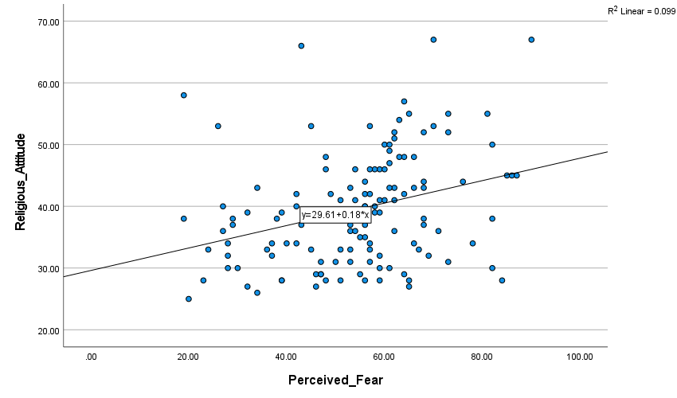****The Linear Relationship Between Religious Attitude and Perceived Fear*

**Figure 2**

*The Linear Relationship Between Choice of Service and Delay of Mental Illness*

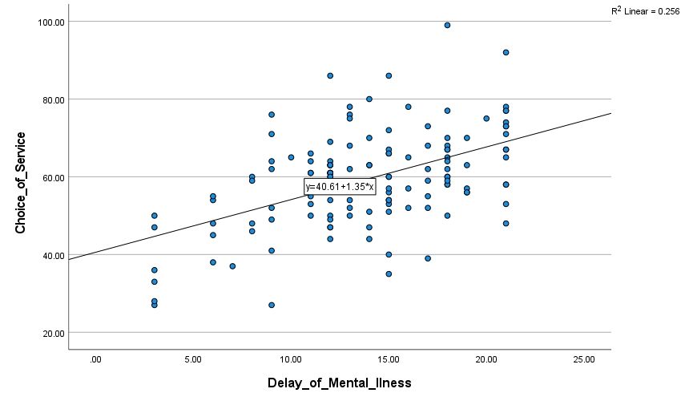

**Figure 3**

*The Linear Relationship Between Perceived Fear and Choice of Service*

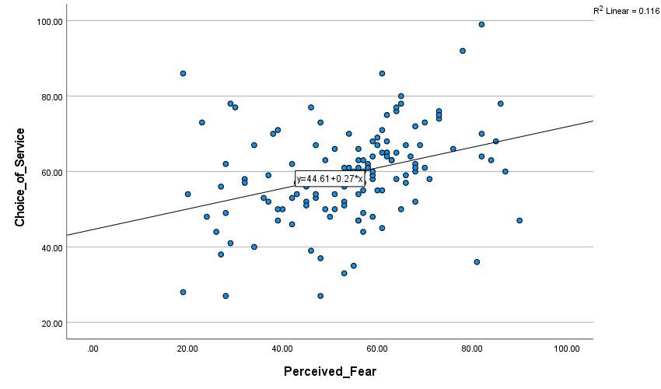

***Assumption 3***

To assure the validity and reliability of the correlation analysis between religious attitudes, perceived fear, and other variables in this study, it is essential to assume that there are no significant outliers. The existence of outliers, which are extreme data points that differ significantly from the rest of the data, can skew correlation coefficients and produce false conclusions. Outliers must be carefully identified and handled since they might change the direction and strength of correlations between variables, thus leading to incorrect conclusions. The following box plot shows the presence or absence or absence of outliers (Senthilnathan, 2019). Figure 4 shows that “Perceived fear” and “Delay of mental illness” do not have outliers. However, “Choice of Service” and “Religious attitude” have negligible outliers that cannot affect correlation analysis,

**Figure 4**

*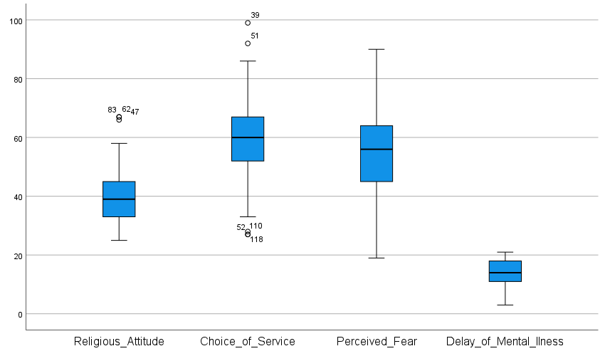Box Plots for The Main Independent and Independent Variables*

***Assumption 4***

Assessing the statistical significance of the Pearson correlation in this study requires adhering to the presumption that the variables should be normally distributed. While determining bivariate normality—the normal distribution of both variables—may be difficult, it can be done more simply by examining the normality of each variable separately (Williams et al., 2022). Researchers make sure that the data for each variable follows a broadly normal distribution by looking at the individual normality of religious attitudes, reported fear, choice of counseling service, and delay of mental illness. Figure 5, Figure 6, Figure 7, and Figure 8 shows that all the variables are normally distributed.

**Figure 4**

*The Distribution of Religious Attitude*

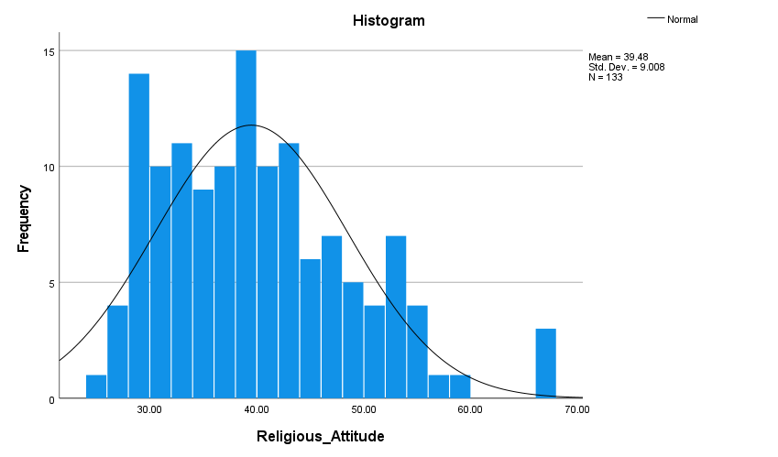

**Figure 5**

*The distribution of Choice*

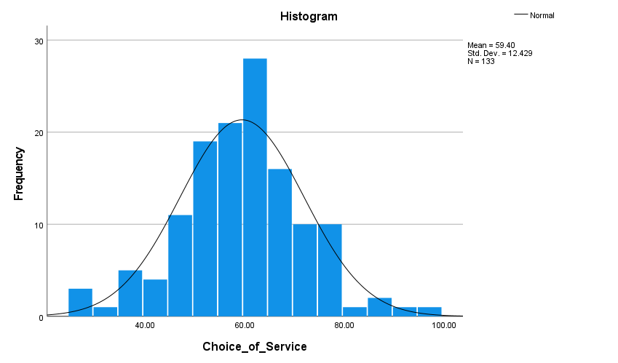*e of Service*

**Figure 6**

*The distribution of perceived fear*

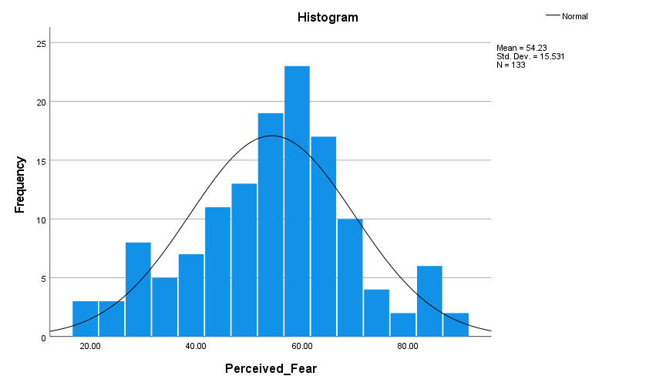

**Figure 7**

*The distribution of Mental Illness*

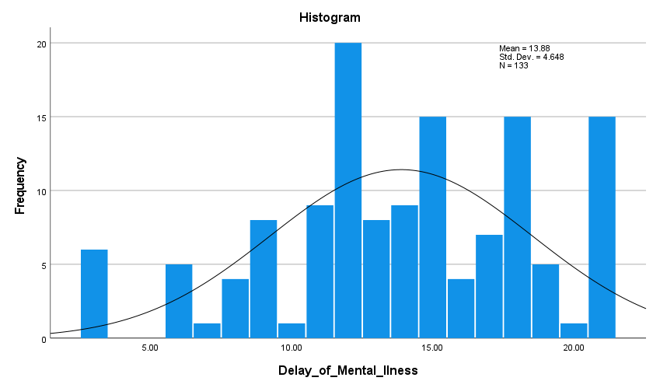

***Remarks***

From the assumption analysis, correlation analysis best fits the data and hence can be used to analyze the research questions and give an informed reference. The following section will analyze the research questions and thus accept or reject the hypothesis at a 0.05 level of significance.

**Research Question Analysis**

This section will analyze the research questions by providing statistical evidence that will lead to either accepting or rejecting the hypothesis.

**RQ 1: What is the correlation between religious attitudes and perceived fear of traditional biomedical and psychological services among Christian adults?**

Table 3 shows the correlation between religious attitudes and perceived fear of traditional biomedical and psychological services among Christian adults of traditional biomedical and psychological services among Christian adults. The correlation coefficient, represented by measures the strength and direction of this relationship. For the variable "Perceived Fear," the Pearson correlation coefficient is 0.314. The correlation is positive, indicating that as religious attitudes increase, perceived fear of traditional services also tends to increase, although the relationship is merely strong.

To determine whether this correlation is statistically significant at the 0.05% level of significance (alpha = 0.05), a p-value of 0.00 means that the correlation is statistically significant at any reasonable level of significance, as it is well below the threshold of 0.05. Therefore, we can reject the null hypothesis that there is no correlation between religious attitudes and perceived fear. Instead, we accept the alternative hypothesis that a significant positive correlation exists between these variables among Christian adults in the studied population.

**Table 3**

*The Correlation between Religious Attitude and Perceived Fear*

|  |  |  |
| --- | --- | --- |
| **Correlations** | | |
|  | | Religious Attitude |
| Religious Attitude | Pearson Correlation | 1 |
| Sig. (2-tailed) |  |
| N | 133 |
| Perceived Fear | Pearson Correlation | .314** |
| Sig. (2-tailed) | 0.05 |
| N | 133 |

**RQ 2: What is the correlation between perceived fear of traditional biomedical and psychological services and choice of service for counseling among Christian adults?**

In Table 4, the correlation coefficient between "Perceived Fear of traditional biomedical and psychological services" and "Choice of counseling service" among Christian adults is 0.341. The correlation coefficient represents the strength and direction of the linear relationship between the two variables. The correlation coefficient of 0.341 indicates a moderate positive correlation between perceived fear and the choice of counseling service. Therefore, as the perceived fear of traditional services increases, the preference for choosing counseling from church-based services also tends to increase. Conversely, as perceived fear decreases, the preference for secular psychological counseling services may become more pronounced.

The p-value associated with the correlation coefficient is reported as 0.000, which means the correlation is significant at the 0.01 level (two-tailed). Since the significance level (alpha) is set at 0.05% (or 0.05), this p-value is smaller than the significance level, indicating that the correlation between perceived fear and choice of service is statistically significant. Therefore, based on the results of the correlation analysis, we can reject the null hypothesis (H0) that there is no correlation between perceived fear and choice of service for counseling among Christian adults. Instead, we can accept the alternative hypothesis (H1) that there is a statistically significant correlation between these variables. The findings suggest that perceived fear plays a role in influencing the choice of counseling service among Christian adults in Southern California religious communities and colleges.

**Table 4**

*The Correlation Between Perceived Fear And Choice Of Counselling Among Adult Christian Adults*

|  |  |  |  |
| --- | --- | --- | --- |
| **Correlations** | | | |
|  | | Perceived fear | Choice of Service |
| Perceived Fear | Pearson Correlation | 1 | .341** |
| Sig. (2-tailed) |  | 0.000 |
| N | 133 | 133 |
| Choice of service | Pearson Correlation | .341** | 1 |
| Sig. (2-tailed) | 0.000 |  |
| N | 133 | 133 |
| **. Correlation is significant at the 0.01 level (2-tailed). | | | |

**RQ 3: What is the correlation between the choice of service for counseling and delay of mental illness reporting among Christian adults?**

With a significance level (p-value) of 0, the Pearson correlation coefficient between these two variables is 0.506. The linear relationship between the two variables is measured by the correlation coefficient, which also indicates its strength and direction. The association is regarded as statistically significant because the p-value is less than the selected significance level of 0.05 (or 5%), denoted as the 0.01 level (2-tailed). This indicates that there is substantial evidence to disprove the null hypothesis, according to which there is no relationship between the "Choice of Service for Counseling" and the "Delay of Mental Illness Reporting." The choice of counseling service and the delay in reporting mental illness are positively correlated, as shown by the positive correlation coefficient of 0.506, which is statistically significant.

This shows that Christian adults may have distinct delays in obtaining mental health support depending on whether they prefer a certain sort of counseling service such as secular psychological counseling or church-based counseling. In conclusion, the given correlation analysis rejects the null hypothesis at the level of significance of 0.05% that there is no link between the "Choice of Service for Counseling" and the "Delay of Mental Illness Reporting" among Christian adults. The statistically significant positive connection suggests that the study participants' choice of counseling service is related to their delayed reporting of mental illness.

|  |  |  |
| --- | --- | --- |
| **Correlations** | | |
|  | | Choice of Service |
| Choice of Service | Pearson Correlation | 1 |
| Sig. (2-tailed) |  |
| N | 133 |
| Delay of Mental Illness | Pearson Correlation | .506** |
| Sig. (2-tailed) | 0 |
| N | 133 |
| **. Correlation is significant at the 0.01 level (2-tailed). | | |

**Summary**

This study investigated the interplay between religious attitudes, perceived fear of traditional biomedical and psychological services, choice of counseling service, and potential delays in reporting mental illness among Christian adults in Southern California religious communities and colleges. The findings demonstrated significant correlations between these variables. Firstly, participants with stronger religious attitudes exhibited higher perceived fear when considering traditional mental health services, indicating that religious beliefs can influence apprehensions towards seeking such support. Secondly, individuals who reported lower perceived fear were more inclined to opt for secular psychological counseling rather than church-based counseling, implying that lower fear levels may facilitate a preference for secular services. Lastly, the study revealed that the choice of counseling service was associated with the length of time individuals might delay seeking mental health support, emphasizing the impact of service preferences on the timing of assistance-seeking.

Overall, the study's results shed light on the complex relationships within the Christian population regarding mental health support-seeking behaviors. The significant correlations underscore the relevance of religious beliefs in shaping perceptions and decisions related to traditional services. These findings hold implications for mental health practitioners and religious leaders, highlighting the importance of addressing perceived barriers and stigma surrounding traditional services to promote timely mental health care access and support among Christian adults.

References

Gogtay, N. J., & Thatte, U. M. (2017). Principles of correlation analysis. *Journal of the Association of Physicians of India*, *65*(3), 78-81.

Kassis, A., & Papps, F. A. (2020). Integrating complementary and alternative therapies into professional psychological practice: An exploration of practitioners’ perceptions of benefits and barriers. *Complementary Therapies in Clinical Practice*, *41*, 101238. https://doi.org/10.1016/j.ctcp.2020.101238

Kohrt, B. A., Ottman, K., Panter-Brick, C., Konner, M., & Patel, V. (2020). Why we heal: The evolution of psychological healing and implications for global mental health. *Clinical Psychology Review*, *82*, 101920. https://doi.org/10.1016/j.cpr.2020.101920

Li, Z., Fu, Y., Wang, C., Sun, H., & Hung, P. (2023). Trends in the availability of community-based psychological counseling services for the oldest-old in China, 2005 to 2018. *Journal of Affective Disorders*, *331*, 405–412. https://doi.org/10.1016/j.jad.2023.03.035

Makowski, D., Ben-Shachar, M. S., Patil, I., & Lüdecke, D. (2020). Methods and algorithms for correlation analysis in R. *Journal of Open Source Software*, *5*(51), 2306.

Pereira, S., Garrido, P., & Colón, M. (2013). 2010 – Mental illness and risk of violence. *European Psychiatry*, *28*, 1. https://doi.org/10.1016/s0924-9338(13)76944-x

Senthilnathan, S. (2019). The usefulness of correlation analysis. *Available at SSRN 3416918*.

Williams, J., Hill, R. R., Pignatiello Jr, J. J., & Chicken, E. (2022). Wavelet analysis of variance box plot. *Journal of Applied Statistics*, *49*(14), 3536-3563.